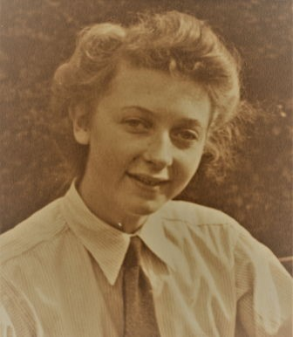
25
th April 1927 - 16th February
2018
Service
8
th March 2018, 12.00 Midday
Wilford Hill, West Bridgford
A Service of Celebration
for the Life of
Patricia Mary Nichols

Processional
'String of Pearls' by Glenn Miller
Blessed are those who mourn, for they shall be comforted Matthew 5:4
Welcome by Sue Megahy and opening prayer

Hymn
Immortal Invisible God Only Wise
Walter Chalmers? Smith
Immortal, invisible, God only wise,
in light inaccessible hid from our eyes,
most blessed, most gracious, the Ancient of Days,
almighty, victorious, thy great name we praise. Unresting, unhasting, and silent as light,
nor wanting nor wasting, thou rulest in might; thy justice like mountains high soaring above
thy clouds which are fountains of goodness and love. To all, life thou givest, to both great and small; in all life thou livest, the true life of all;
we blossom and flourish as leaves on the tree,
and wither and perish - but nought changeth thee. Great Father of Glory, pure Father of Light,
thine angels adore thee, all veiling their sight; all laud we would render: O help us to see
'tis only the splendour of light hideth thee.
Tributes
Family and friends

Reflection
'How do we let a mother go?' by Anon
How do we let a mother go?
How do we say "I'm ready to go on now, without you"?
Can we know what that might really mean? And suddenly, that moment is all upon us.
There is no turning back.
And we know what grief that is.
And we know guilt, and love, and things left undone. But there is also a quiet peace.
Peace and acceptance.
And overwhelming love, maybe we weren't aware.
Waves and waves of conflicting emotion. And time for laughter too.
Memories we hadn't bothered much lately to recall, All come flooding back in company shared. And it's all about you mum.
And there is our gratitude, so much of that.
That we had you - such a wonderful mother.
Bright and shining, nobody's fool.
Independent, but humble too. Fun, always adventurous.
Try to prepare, and in some way we fail, Be it in ways subtle or looming.
As a part of you has passed away. Much more remains in us.
Every day, as long as we are here.
This may be our final tribute together.
A day to celebrate your life and to say goodbye. But to us, never forgotten.
Every day, I will celebrate in some small way.
Just how you shaped me, my life.
Always to remember my good fortune,
As my mother, a woman and our loyal friend.

Reading
Ecclesiastes 3 - A time for everything Chapter 3, Verses 1-8 (edited)
To everything there is a season,
and a time to every purpose under the heaven: a time to be born and a time to die;
a time to plant, and a time to pluck up that which is planted; a time to kill, and a time to heal;
a time to break through, and a time to build up; a time to weep and a time to laugh;
a time to mourn, and a time to dance;
a time to cast away stones, and a time to gather stones together; a time to embrace, and a time to refrain from embracing; a time to see, and a time to lose; a time to keep, and a time to cast away; a time to rend,
and a time to sow; a time to keep silence, and a time to speak; a time to love, and a time to hate; a time for war, and a time for peace.

Prayers Lord's Prayer
Our Father
Who art in heaven
Hallowed be thy name
Thy kingdom come
Thy will be done
On earth as it is in heaven
Give us this day our daily bread
And forgive us our trespasses
As we forgive those who trespass against us
And lead us not into temptation
But deliver us from evil
For Thine is the kingdom, the power and the glory
For ever and ever
Amen

Hymn
All Things Bright And Beautiful
Cecil Frances Alexander
All things bright and beautiful, all creatures great and small,
all things wise and wonderful, the Lord God made them all. Each little flower that opens, each little bird that sings,
he made their glowing colours, he made their tiny wings.
The purple-headed mountain, the river running by,
the sunset and the morning, that brightens up the sky;
The cold wind in the winter, the pleasant summer sun,
the ripe fruits in the garden, he made them every one;
The tall trees in the greenwood, the meadows for our play, the rushes by the water, to gather every day;
He gave us eyes to see them, and lips that we might tell
how great is God almighty, who has made all things well.
Commendation
Committal

Final Prayer

Recessional
'Simply The Best' by Tina Turner
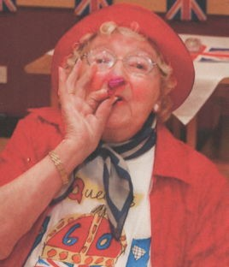
Donations in memory of Pat
The British Legion
May be placed in the donation box provided or sent care of
A. W. Lymn, 59 Main Road, Radcliffe-on-Trent,
Nottingham, NG12 2BJ.
All are invited to join the family afterwards at The Manvers
Arms, Radcliffe-on-Trent.
Patricia Mary Nichols

