A Celebration of Life
for
Madhukanta Jaswantbhai Gohil

9th July 1940 ~ 5th September 2022
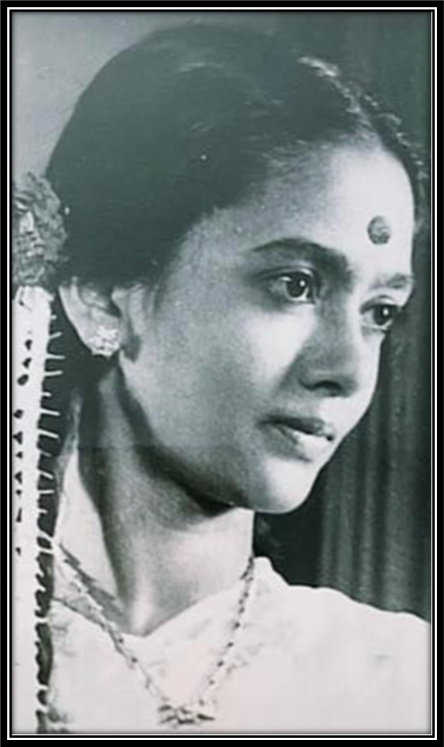

The Oaks, Havant Crematorium
Tuesday 20th September 2022
10.45 a.m.

Officiant ~ Mrs Sylvia Corke

Opening Music
‘Om Jai Jagdesh Hare’ ~ Rattan Mohan Sharma, Shweta Pandit

Opening Address

Poem ~ A Life Worth Celebrating

We are here to celebrate your life.
And the measure of its worth.
And every single life you touched.
While you were on this earth.
We wish to pay our last respects.
That's why we all are here.
To thank you for your friendship.
And all the memories we hold dear.
It’s been a privilege to have known you.
We were family and friends.
And we will carry you in spirit.
Until we meet up once again.

Tributes to Madhukanta
Sylvia Corke
Vinay Gohil ~ read by Sylvia Corke

Music for Personal Reflection with Visual Life Tribute
‘Manipuri Hare Krishna’ ~ The Hanumen

Second Address

Poem
A Poem for Mum ~ written and recited by Manisha Walsh

Committal and Commendation

Thanks

Closing Music
‘Govinda’ ~ Radha Krsna Temple

“Those we love don’t go away,
They walk beside us every day
Unseen, unheard, but always near,
still loved, still missed, and very dear”
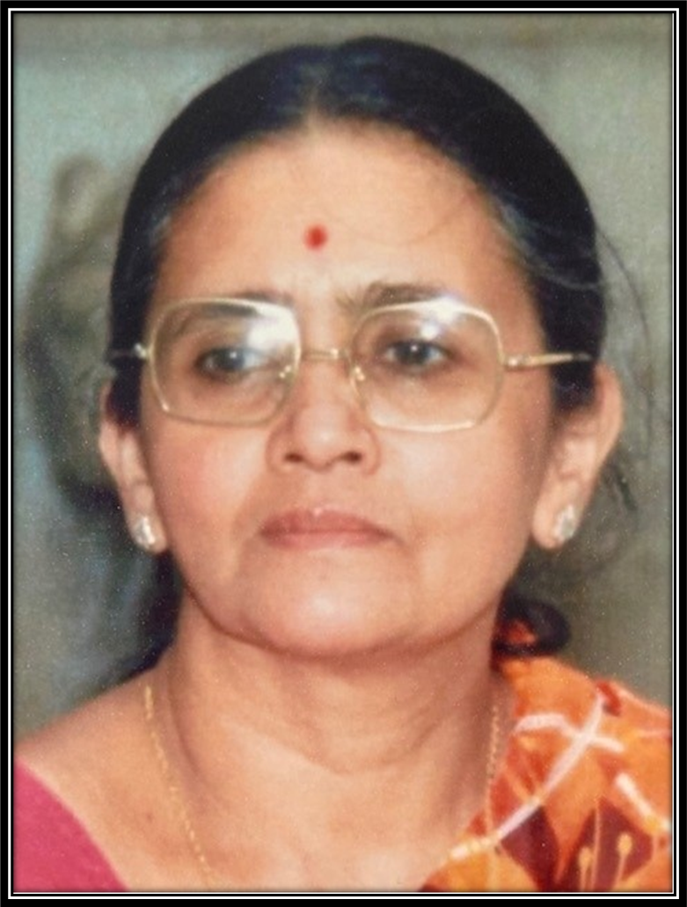

Madhukanta’s family warmly thank you for your attendance here today and invite you to join them for light refreshments following the service at Jayesh and Kate’s home, to share fond memories of Madhukanta and to continue to celebrate her life.



12 The Pallant, Havant, Hampshire PO9 1BE
Telephone (023) 9248 4844
www.leefletcherfuneralservices.co.uk

Funeral Conducted by Mr Lee Fletcher, Dip. F.D. L.M.B.I.F.D

